Lab Manual: MQTT with Arduino Uno and ESP32

1. Overview
In this lab an Arduino Uno reads a light sensor (LDR) and drives an active buzzer, while an ESP32 acts as its WiFi gateway to an MQTT broker. Students publish light levels, switch the buzzer remotely from a laptop or phone, and build a "dark alarm" controlled entirely through MQTT topics.
Aim: Build an MQTT-connected sensor and actuator node using an Arduino Uno for I/O and an ESP32 as the MQTT client, and use publish/subscribe, QoS, retained messages and Last Will to monitor and control it.
Why these two devices: the Uno has no WiFi, so it handles the analog sensor and the buzzer; the ESP32 has WiFi but is used only as the network gateway. This split is how many real IoT products add connectivity to an existing microcontroller.
Why these two components: the LDR gives a changing analog value to publish; the active buzzer is an output to subscribe to and control. Together they cover both directions of MQTT.
Learning objectives. By the end of the lab you will be able to:
- Explain the roles of broker, publisher and subscriber, and design a topic hierarchy.
- Publish and subscribe from the command line, using the + and # wildcards.
- Send data between an Uno and an ESP32 over a level-shifted UART link with a simple text protocol.
- Program an ESP32 to connect to WiFi and an MQTT broker, publish sensor data and act on commands.
- Use retained messages, QoS 0/1 and a Last Will and Testament (LWT) and explain what each one changes.
- Build an automation rule (dark → buzzer) whose threshold is set remotely over MQTT.
Item | Detail
Duration | 3 hours (Part A 30 min, Part B 45 min, Part C 60 min, Part D 30 min, write-up 15 min)
Group size | 2 students per bench
Prerequisites | Arduino C++ basics, analogRead/digitalWrite, uploading to Uno and ESP32, voltage divider basics
Deliverables | Observation tables, MQTT Explorer screenshots, answers to viva questions

2. Background theory
MQTT is a lightweight publish/subscribe protocol over TCP (port 1883). Devices never talk to each other directly: every message goes through a broker, which forwards it to every client subscribed to that topic.

2.1 Broker, publishers and subscribers
- Broker: the server that receives all messages and routes them (this lab: Mosquitto).
- Client: any device or program connected to the broker. A client can publish, subscribe, or both. Each client has a unique client ID.
- Publish: send a message (a payload, any bytes) to a topic.
- Subscribe: ask the broker for every message on a topic or topic pattern.
Publishers and subscribers are decoupled: the ESP32 does not know who reads its light level, and the laptop does not know the buzzer's IP address.

2.2 Topics and wildcards
Topics are UTF-8 strings split into levels by /, e.g. iotlab/b07/ldr/percent. They are case-sensitive and created on first use. Wildcards are allowed only when subscribing:
Pattern | Matches | Does not match
iotlab/b07/ldr/+ | iotlab/b07/ldr/raw, iotlab/b07/ldr/percent | iotlab/b07/buzzer/set
iotlab/+/ldr/percent | That topic on every bench | iotlab/b07/ldr/raw
iotlab/b07/# | Everything under bench 07 | iotlab/b08/status
# | Every topic on the broker | —
+ replaces exactly one level; # replaces any number of levels and must be last.

2.3 Quality of Service (QoS)
QoS | Name | Delivery | Handshake
0 | At most once | May be lost, never duplicated | PUBLISH only
1 | At least once | Never lost, may be duplicated | PUBLISH → PUBACK
2 | Exactly once | Never lost or duplicated | PUBLISH → PUBREC → PUBREL → PUBCOMP
The PubSubClient library used on the ESP32 publishes at QoS 0 and can subscribe at QoS 0 or 1. QoS is chosen per message by the sender and per subscription by the receiver; the broker delivers at the lower of the two.

2.4 Retained messages
A message published with the retain flag is stored by the broker as the last known value for that topic. Any client that subscribes later receives it immediately. Use retain for state ("buzzer is OFF", "device is online"), not for one-off events ("beep now").

2.5 Keep-alive and Last Will (LWT)
When a client connects it may register a Last Will: a topic, payload and retain flag the broker publishes on its behalf if the client disappears without a clean disconnect (power cut, WiFi lost). The broker notices this when no packet arrives within 1.5 × the keep-alive interval (PubSubClient default: 15 s). Combined with retain, this gives every subscriber a reliable online / offline status.

3. System architecture and topic map
Every bench builds the same system: the Uno handles the LDR and buzzer, the ESP32 is the only device on the network, and the broker connects it to every other client in the lab.
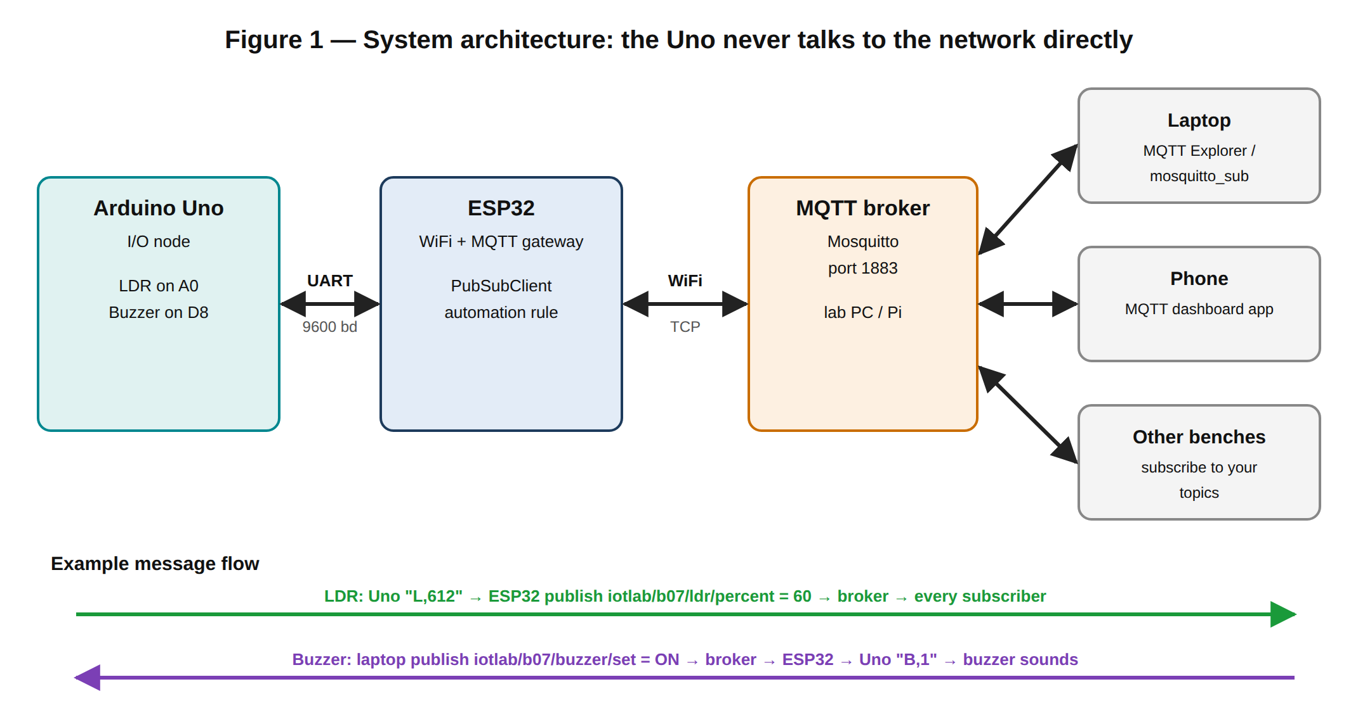

3.1 Topic map
Replace b07 with your bench number (two digits: b01, b02 …). Every topic your bench uses starts with iotlab/<bench>/.
Topic | Published by | Payload | Retain | When
iotlab/b07/status | ESP32 (and broker as LWT) | online / offline | Yes | On connect / on unexpected disconnect
iotlab/b07/ldr/raw | ESP32 | 0–1023 | No | Every 2 s
iotlab/b07/ldr/percent | ESP32 | 0–100 | No | Every 2 s
iotlab/b07/buzzer/set | Laptop / phone | ON, OFF, BEEP | No | Any time (command)
iotlab/b07/buzzer/state | ESP32 | ON / OFF | Yes | Whenever the buzzer changes
iotlab/b07/config/threshold | Laptop / phone | 0–100 (light %) | Yes | When you change it (Part D)
iotlab/b07/config/auto | Laptop / phone | ON / OFF | Yes | Enables the dark alarm (Part D)
iotlab/b07/alarm | ESP32 | DARK / LIGHT | Yes | Only when the state flips (Part D)
The split between buzzer/set (a command) and buzzer/state (what actually happened) is deliberate: a dashboard should display state, never assume a command worked.

3.2 Uno ↔ ESP32 serial protocol
The two boards exchange short text lines at 9600 baud, each ending in a newline (\n). Text keeps the link easy to watch in Serial Monitor.
Direction | Line | Meaning
Uno → ESP32 | L,612 | LDR raw reading (0–1023), sent every 500 ms
Uno → ESP32 | S,1 / S,0 | Buzzer is now on / off (acknowledgement)
ESP32 → Uno | B,1 | Buzzer on
ESP32 → Uno | B,0 | Buzzer off
ESP32 → Uno | B,2 | Three short beeps, then off

4. Kit, software and circuit

4.1 Kit per bench
Item | Qty | Notes
Arduino Uno R3 + USB-B cable | 1 | I/O node
ESP32 DevKit V1 (ESP32-WROOM-32) + USB cable | 1 | WiFi/MQTT gateway
LDR (photoresistor, 5 mm, GL5528 or similar) | 1 | Light sensor
Active buzzer, 5 V, 2-pin | 1 | Sounds on a DC level; longer leg is +
Resistors: 10 kΩ × 1, 1 kΩ × 1, 2 kΩ × 1 | 3 | 10 kΩ for the LDR divider; 1 kΩ + 2 kΩ for the UART level shift
Breadboard + jumper wires | 1 set
Laptop with WiFi | 1 | Programming, Serial Monitor, MQTT Explorer
Smartphone (optional) | 1 | MQTT dashboard app
Shared lab equipment (instructor): one WiFi router or access point for the lab, and one PC or Raspberry Pi on that network running the Mosquitto broker.

4.2 Software
- Arduino IDE 2.x with the ESP32 board package by Espressif (version 3.x)
- Library PubSubClient by Nick O'Leary (Library Manager) — ESP32 only
- SoftwareSerial is built into the Uno core; no install needed
- MQTT Explorer (desktop app, Windows/macOS/Linux) and the Mosquitto clients (mosquitto_pub, mosquitto_sub)
- Optional phone app: any MQTT dashboard app (e.g. "IoT MQTT Panel" on Android, "MQTTool" on iOS)
Broker set-up (instructor, once): install Mosquitto on the broker PC and create mosquitto.conf containing:
listener 1883 0.0.0.0
allow_anonymous true
Start it with mosquitto -c mosquitto.conf -v so the console shows every connect and subscribe. Write the broker's IP address on the board (e.g. 192.168.1.10). Mosquitto 2.x refuses network clients without these two lines. If no local broker is possible, broker.hivemq.com works as a fallback, but it is public: anyone can read your topics.

4.3 Circuit
Build the circuit with both USB cables unplugged, then have it checked before powering up.
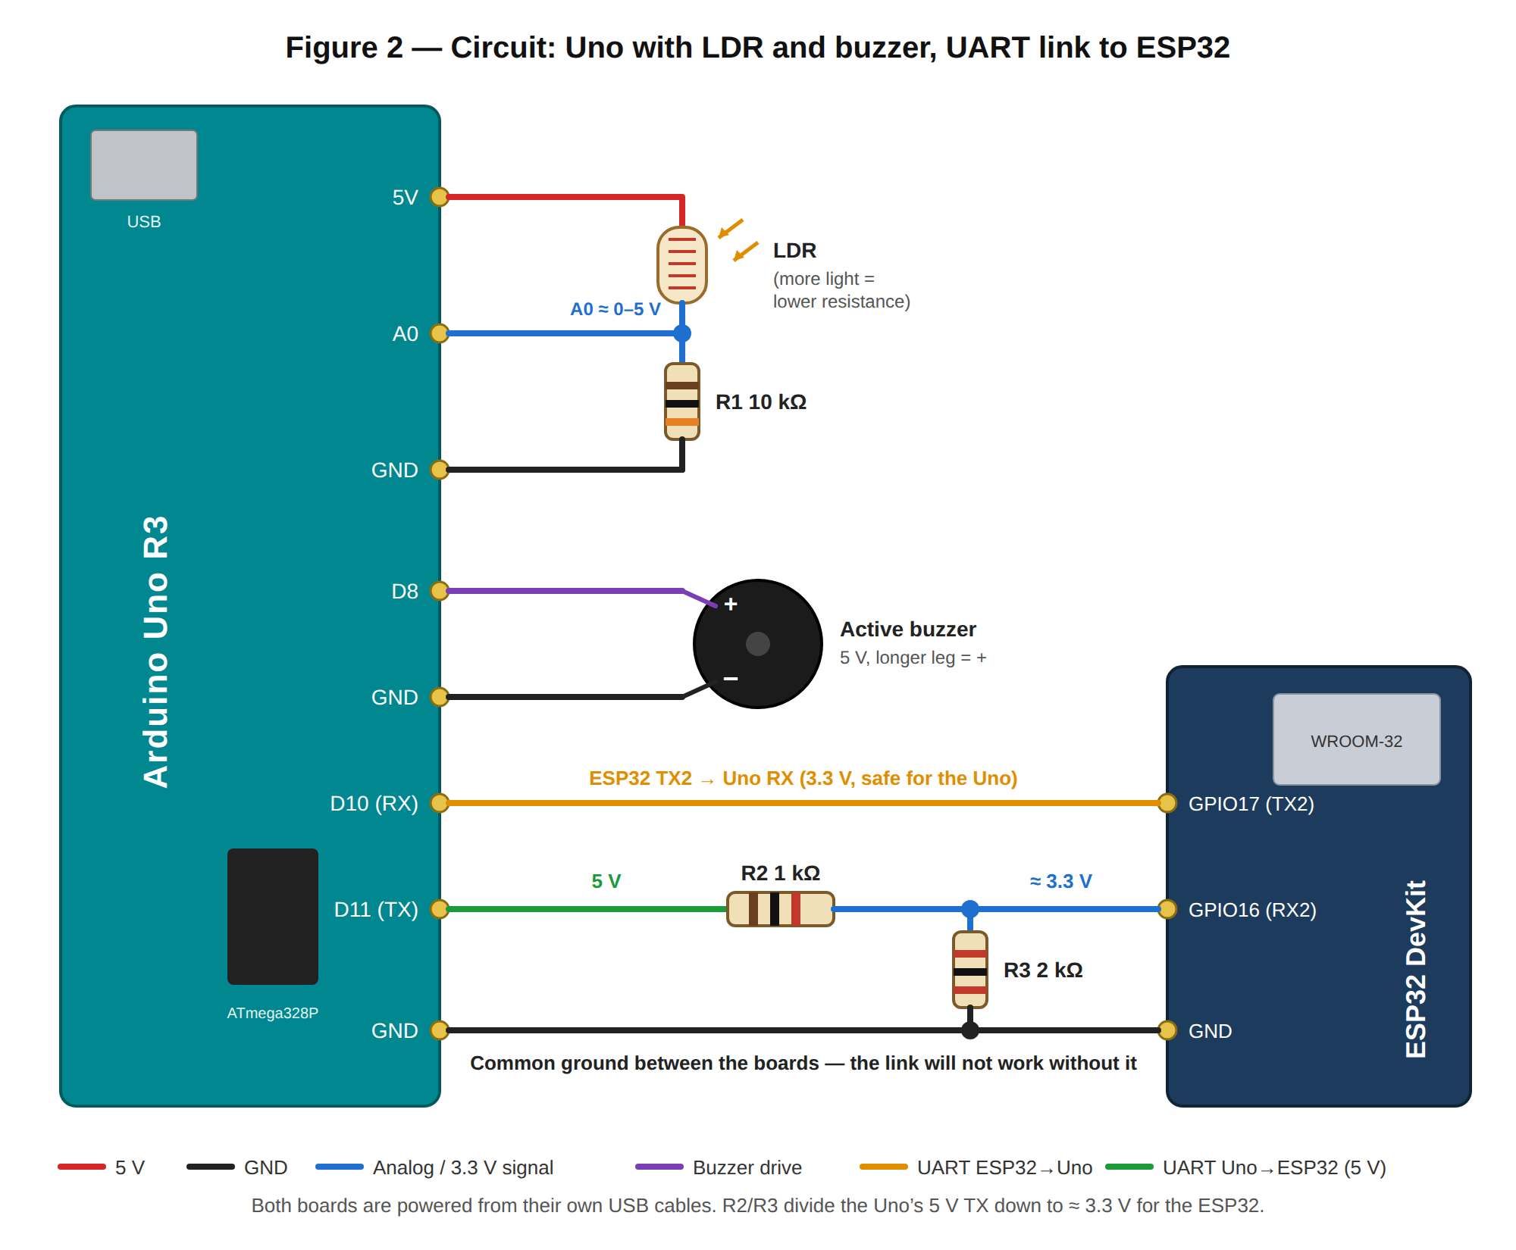
From | To | Purpose
Uno 5V | LDR leg 1 | Top of light divider
LDR leg 2 | Uno A0, and R1 (10 kΩ) to GND | Divider output: brighter = higher voltage
Uno D8 | Buzzer + (long leg) | Buzzer drive
Buzzer − | Uno GND
ESP32 GPIO17 (TX2) | Uno D10 (SoftwareSerial RX) | ESP32 → Uno, 3.3 V is read as HIGH by the Uno
Uno D11 (SoftwareSerial TX) | R2 (1 kΩ) → ESP32 GPIO16 (RX2); R3 (2 kΩ) GPIO16 → GND | Uno → ESP32, 5 V divided to ≈ 3.3 V
Uno GND | ESP32 GND | Common ground — essential
Why the divider: the Uno drives its pins to 5 V but ESP32 inputs are rated for 3.3 V. 5 V × 2 kΩ / (1 kΩ + 2 kΩ) ≈ 3.3 V. The other direction needs nothing, because 3.3 V is above the Uno's HIGH threshold (3.0 V).
Why SoftwareSerial on D10/D11: the Uno's hardware serial (D0/D1) is shared with its USB port, so using it would block uploads and Serial Monitor.

5. Part A — Broker and MQTT client tools (30 min)
Before touching hardware, you use MQTT from the laptop alone, so that later you can tell a wiring or code fault from a broker or topic fault.
In all commands, replace BROKER with the broker IP on the board and b07 with your bench. Open two terminal windows side by side: one subscriber, one publisher.

5.1 Procedure
- Subscribe to your bench. In terminal 1:
mosquitto_sub -h BROKER -t "iotlab/b07/#" -v
-v prints the topic in front of each message. Leave it running.
- Publish. In terminal 2:
mosquitto_pub -h BROKER -t "iotlab/b07/test" -m "hello from b07"
Confirm the message appears in terminal 1. Record it in Table 9.1.
- Topic mismatch. Publish to iotlab/B07/test (capital B) and to iotlab/b07/test/ (trailing slash). Note whether terminal 1 shows them, and why.
- Wildcards. Stop terminal 1 (Ctrl+C) and subscribe in turn to each pattern below. For each, publish to iotlab/b07/ldr/raw, iotlab/b07/buzzer/set and iotlab/b08/ldr/raw, and tick which arrive in Table 9.1:
  - iotlab/b07/+/raw
  - iotlab/+/ldr/raw
  - iotlab/b07/#
- Retained message. Stop the subscriber. Publish with the retain flag:
mosquitto_pub -h BROKER -t "iotlab/b07/test/state" -m "OFF" -r
Now start mosquitto_sub -h BROKER -t "iotlab/b07/test/state" -v. The message arrives even though it was sent before you subscribed. Repeat without -r and compare.
- Clear the retained message by publishing an empty retained payload: mosquitto_pub -h BROKER -t "iotlab/b07/test/state" -r -n
- QoS. Publish with -q 0 and then -q 1, adding -d (debug) to both. Copy the packet names printed (PUBLISH, PUBACK) into Table 9.1.
- MQTT Explorer. Open MQTT Explorer, connect to BROKER port 1883, and find your iotlab/b07 tree. Publish hello to iotlab/b07/test from its Publish panel and confirm it in the terminal. Keep MQTT Explorer open for the rest of the lab.
- Whole-lab view. Briefly subscribe to iotlab/#. How many benches are publishing? Why would subscribing to # be a bad idea on a public broker?

6. Part B — Uno I/O node and serial link (45 min)
The Uno reads the LDR, drives the buzzer, and talks to the ESP32 using the line protocol in section 3.2. You test it in two steps: the Uno on its own, then the UART link through a simple ESP32 bridge sketch.

6.1 Uno sketch
The Uno accepts commands both from the ESP32 and from its own Serial Monitor, so you can test the buzzer before any networking exists.

#include <SoftwareSerial.h>

#define LDR_PIN A0
#define BUZZER_PIN 8

SoftwareSerial link(10, 11);

String linkBuf = "", usbBuf = "";
unsigned long lastSend = 0;

void setBuzzer(bool on) {
digitalWrite(BUZZER_PIN, on ? LOW : HIGH);
link.print("S,");
link.println(on ? 1 : 0);
Serial.println(on ? "Buzzer ON" : "Buzzer OFF");
}

void beep3() {
for (int i = 0; i < 3; i++) {
digitalWrite(BUZZER_PIN, LOW);
delay(150);
digitalWrite(BUZZER_PIN, HIGH);
delay(150);
}
setBuzzer(false);
}

void handleLine(String line) {
line.trim();
if (line.length() == 0) return;

Serial.print("CMD: ");
Serial.println(line);

if (line == "B,1") setBuzzer(true);
else if (line == "B,0") setBuzzer(false);
else if (line == "B,2") beep3();
else Serial.println("Unknown command");
}

void readLines(Stream &s, String &buf) {
while (s.available()) {
char c = s.read();

if (c == '\n') {
handleLine(buf);
buf = "";
} else if (buf.length() < 20) {
buf += c;
}
}
}

void setup() {
pinMode(BUZZER_PIN, OUTPUT);
digitalWrite(BUZZER_PIN, HIGH);

Serial.begin(9600);
link.begin(9600);

Serial.println("Uno I/O node ready");
}

void loop() {
readLines(link, linkBuf);
readLines(Serial, usbBuf);

if (millis() - lastSend >= 500) {
lastSend = millis();

int raw = analogRead(LDR_PIN);

link.print("L,");
link.println(raw);

Serial.print("L,");
Serial.println(raw);
}
}

6.2 ESP32 bridge test sketch
This sketch only copies bytes between the UART link and the ESP32's USB Serial Monitor. It proves the wiring and level shifter work before MQTT is added.
#define RXD2 16
#define TXD2 17
void setup() {
Serial.begin(115200); // USB
Serial2.begin(9600, SERIAL_8N1, RXD2, TXD2); // link to Uno
Serial.println("Bridge test: type B,1 / B,0 / B,2");
}
void loop() {
while (Serial2.available()) Serial.write(Serial2.read()); // Uno -> PC
while (Serial.available()) Serial2.write(Serial.read()); // PC -> Uno
}

6.3 Procedure
- Upload the Uno sketch. Open the Uno's Serial Monitor at 9600 baud, line ending Newline. Confirm L,<number> lines twice a second.
- Calibrate the LDR. Record the raw value in Table 9.2 for: torch/phone light on the LDR, normal room light, hand cupped over it, and LDR fully covered with a finger.
- Type B,1, B,0 and B,2 into the Uno's Serial Monitor. Confirm the buzzer and the Buzzer ON/OFF replies.
- Close the Uno's Serial Monitor (keep the Uno powered). Upload the bridge sketch to the ESP32 and open its Serial Monitor at 115200 baud, line ending Newline.
- Confirm the Uno's L,<number> and S,<n> lines now appear in the ESP32's monitor — data is crossing the level-shifted link.
- Type B,1 into the ESP32's monitor. The Uno's buzzer should sound — data is crossing the other way. Then B,0.
- Unplug the common GND wire for 5 s and watch the ESP32 monitor. Record what happens, then reconnect it.

7. Part C — ESP32 MQTT gateway (60 min)
The ESP32 joins WiFi, connects to the broker with a Last Will, publishes the Uno's light readings, and forwards buzzer commands back to the Uno. The same sketch already contains the dark-alarm logic used in Part D; it stays off until you enable it over MQTT.

7.1 Gateway sketch
Install PubSubClient first. Edit the four lines marked edit.

#include <WiFi.h>
#include <PubSubClient.h>

const char *WIFI_SSID = "YOUR_WIFI_NAME";
const char *WIFI_PASS = "YOUR_WIFI_PASSWORD";
const char *BROKER = "YOUR_BROKER_IP";
#define BENCH "YOUR_BENCH"

#define RXD2 16
#define TXD2 17
#define T(x) "iotlab/" BENCH "/" x

WiFiClient net;
PubSubClient mqtt(net);

int ldrRaw = -1;
int threshold = 30;
bool autoMode = false;
bool alarmDark = false;
bool alarmKnown = false;
String unoBuf = "";
unsigned long lastPub = 0;

void onMessage(char *topic, byte *payload, unsigned int len) {
String msg;

for (unsigned int i = 0; i < len; i++) {
msg += (char)payload[i];
}

msg.trim();
String t = topic;

Serial.printf("RX %s = %s\n", topic, msg.c_str());

if (t == T("buzzer/set")) {
if (msg.equalsIgnoreCase("ON")) {
Serial2.println("B,1");
} else if (msg.equalsIgnoreCase("OFF")) {
Serial2.println("B,0");
} else if (msg.equalsIgnoreCase("BEEP")) {
Serial2.println("B,2");
} else {
Serial.println("Ignored: unknown buzzer command");
}
} else if (t == T("config/threshold")) {
int v = msg.toInt();

if (msg.length() > 0 && v >= 0 && v <= 100) {
threshold = v;
alarmKnown = false;
Serial.printf("Threshold set to %d\n", threshold);
} else {
Serial.println("Ignored: invalid threshold");
}
} else if (t == T("config/auto")) {
if (msg.equalsIgnoreCase("ON")) {
autoMode = true;
} else if (msg.equalsIgnoreCase("OFF")) {
autoMode = false;
Serial2.println("B,0");
} else {
Serial.println("Ignored: invalid auto setting");
return;
}

alarmKnown = false;
Serial.printf("Auto mode = %s\n", autoMode ? "ON" : "OFF");
}
}

void handleUno(String line) {
line.trim();

if (line.startsWith("L,")) {
ldrRaw = line.substring(2).toInt();
} else if (line == "S,1" || line == "S,0") {
bool on = (line == "S,1");

mqtt.publish(T("buzzer/state"), on ? "ON" : "OFF", true);
Serial.printf("PUB buzzer/state = %s\n", on ? "ON" : "OFF");
}
}

void readUno() {
while (Serial2.available()) {
char c = Serial2.read();

if (c == '\n') {
handleUno(unoBuf);
unoBuf = "";
} else if (unoBuf.length() < 20) {
unoBuf += c;
}
}
}

void connectWiFi() {
WiFi.mode(WIFI_STA);
WiFi.begin(WIFI_SSID, WIFI_PASS);

Serial.print("WiFi");

while (WiFi.status() != WL_CONNECTED) {
delay(500);
Serial.print(".");
}

Serial.printf("\nIP %s\n", WiFi.localIP().toString().c_str());
}

void connectMQTT() {
while (!mqtt.connected()) {
String id = String("esp32-" BENCH "-") +
String((uint32_t)ESP.getEfuseMac(), HEX);

Serial.printf("MQTT connect as %s ... ", id.c_str());

if (mqtt.connect(id.c_str(), T("status"), 1, true, "offline")) {
Serial.println("OK");

mqtt.publish(T("status"), "online", true);
mqtt.subscribe(T("buzzer/set"), 1);
mqtt.subscribe(T("config/#"), 1);
} else {
Serial.printf("failed, rc=%d, retry in 2 s\n", mqtt.state());
delay(2000);
}
}
}

void setup() {
Serial.begin(115200);
Serial2.begin(9600, SERIAL_8N1, RXD2, TXD2);

connectWiFi();

mqtt.setServer(BROKER, 1883);
mqtt.setCallback(onMessage);
mqtt.setBufferSize(512);
}

void loop() {
if (WiFi.status() != WL_CONNECTED) {
connectWiFi();
}

if (!mqtt.connected()) {
connectMQTT();
}

mqtt.loop();
readUno();

if (ldrRaw >= 0 && millis() - lastPub >= 2000) {
lastPub = millis();

int pct = map(ldrRaw, 0, 1023, 100, 0);
pct = constrain(pct, 0, 100);

char buf[12];

snprintf(buf, sizeof(buf), "%d", ldrRaw);
mqtt.publish(T("ldr/raw"), buf);

snprintf(buf, sizeof(buf), "%d", pct);
mqtt.publish(T("ldr/percent"), buf);

Serial.printf("PUB ldr raw=%d percent=%d\n", ldrRaw, pct);

bool dark = pct < threshold;

if (!alarmKnown || dark != alarmDark) {
alarmKnown = true;
alarmDark = dark;

mqtt.publish(T("alarm"), dark ? "DARK" : "LIGHT", true);

Serial.printf("PUB alarm = %s\n", dark ? "DARK" : "LIGHT");

if (autoMode) {
Serial2.println(dark ? "B,1" : "B,0");
}
}
}
}

7.2 Procedure
- Keep the Uno running its Part B sketch. Edit the four edit lines, upload the gateway sketch to the ESP32 and open its Serial Monitor at 115200 baud.
- Confirm the sequence: WiFi.... → IP … → MQTT connect as esp32-b07-… OK → PUB ldr … every 2 s. If rc=-2 appears, see Troubleshooting.
- In MQTT Explorer, expand iotlab/b07. Confirm status = online, and ldr/raw and ldr/percent updating. Open the ldr/percent topic and use its history graph while you cover and uncover the LDR. Screenshot it.
- Control the buzzer from a terminal:
mosquitto_pub -h BROKER -t "iotlab/b07/buzzer/set" -m ON
mosquitto_pub -h BROKER -t "iotlab/b07/buzzer/set" -m OFF
mosquitto_pub -h BROKER -t "iotlab/b07/buzzer/set" -m BEEP
For each, check the buzzer, the ESP32 log (RX …) and the buzzer/state topic.
- Send on (lower case), then MAYBE. Record which are accepted and why.
- Retained state: start a fresh mosquitto_sub -h BROKER -t "iotlab/b07/buzzer/state" -v. It shows the current state immediately. Now subscribe to iotlab/b07/ldr/percent the same way — explain why you wait up to 2 s for the first value.
- Latency: with the ESP32 log visible, send ON and estimate the delay until the buzzer sounds. Repeat 3 times.
- Press EN/RESET on the ESP32. Watch status in MQTT Explorer and the reconnection in the log. Record the time to reconnect.
- (Optional) Set up a phone MQTT dashboard: a gauge on iotlab/b07/ldr/percent, a switch publishing ON/OFF to iotlab/b07/buzzer/set, and an indicator on iotlab/b07/buzzer/state.

8. Part D — Dark alarm, Last Will and cross-bench
You now turn the node into a "dark alarm": when the light level drops below a threshold, the buzzer sounds. The threshold and the on/off switch live on the broker as retained messages, so the ESP32 picks them up again after any reboot.

8.1 Dark alarm with retained configuration
- Using Table 9.2, choose a threshold in light % halfway between "room light" and "hand cupped" (percent = raw × 100 / 1023).
- Publish the configuration with retain:
mosquitto_pub -h BROKER -t "iotlab/b07/config/threshold" -m 30 -r
mosquitto_pub -h BROKER -t "iotlab/b07/config/auto" -m ON -r
- Cover the LDR. Within 2 s, alarm changes to DARK and the buzzer sounds. Uncover it: LIGHT, buzzer off.
- Hold your hand so the light sits right at the threshold. Watch alarm in MQTT Explorer and describe what happens to the buzzer.
- Press RESET on the ESP32. After it reconnects, check the log for RX iotlab/b07/config/threshold = 30 — the broker delivered the retained settings automatically.
- Repeat step 2 for the threshold without -r (use 40), reset the ESP32 again and read the threshold it uses. Explain the difference. Then republish 30 with -r.
- Turn the alarm off: publish OFF (retained) to iotlab/b07/config/auto.

8.2 Last Will and Testament
- Subscribe: mosquitto_sub -h BROKER -t "iotlab/b07/status" -v. It shows online (retained).
- Pull the ESP32's USB cable (a crash, not a clean disconnect). Start a stopwatch.
- Record the time until offline appears. Compare with the keep-alive (15 s) and the 1.5 × rule from section 2.5.
- Plug the ESP32 back in. Confirm online returns.
- Start a brand-new subscriber to iotlab/+/status. Every bench's current status appears at once. Explain why.

8.3 Cross-bench (Optional)
Pair up with the next bench (b07 with b08, and so on).
- Subscribe to your partner's light level: mosquitto_sub -h BROKER -t "iotlab/b08/ldr/percent" -v. Ask them to cover their LDR and watch the change.
- With their permission, send BEEP to iotlab/b08/buzzer/set. Their buzzer sounds although you never touched their hardware or knew its IP address.
- Discuss: what stops any student, or anyone on a public broker, from doing step 2 without permission? Note your answer for the viva.

